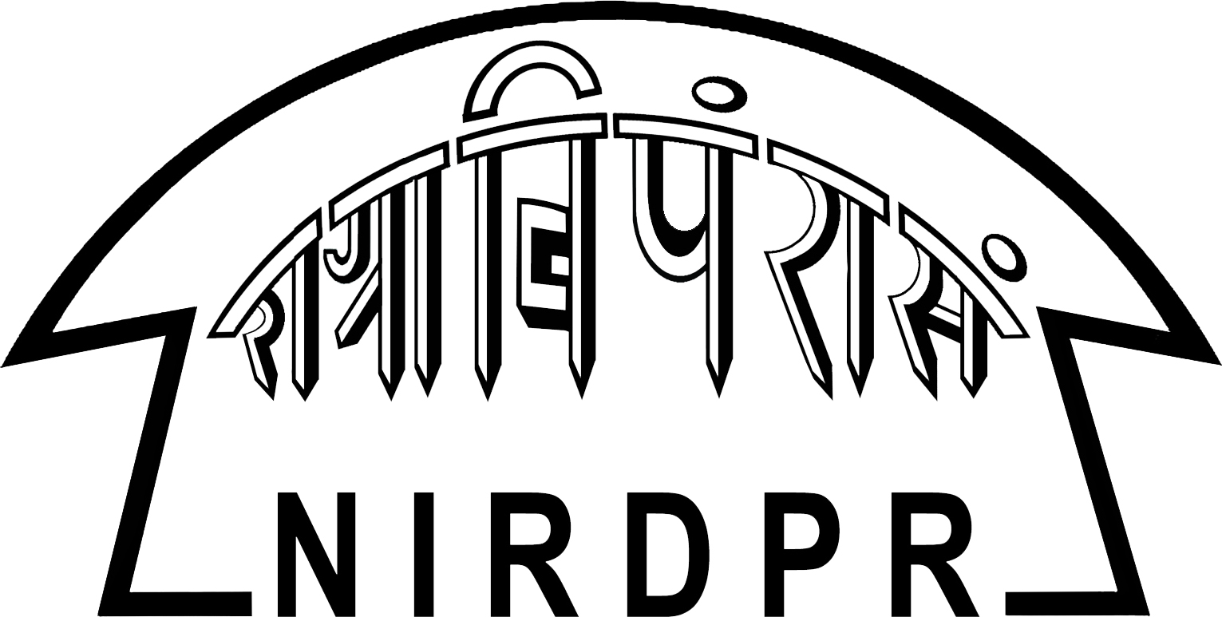
NATIONAL INSTITUTE OF RURAL DEVELOPMENT AND PANCHAYATI RAJ
(Ministry of Rural Development, Government of India)
Rajendranagar, Hyderabad-500030, AP, India

Centre for PG Studies & Distance Education
Post Graduate Diploma in Rural Development Management (PGDRDM): 2018 – 2019

APPLICATION FORM INTERNATIONAL IN-SERVICE CANDIDATE
Application Number Office use only
Please read the ‘Specific & General Instructions’ in the last page before filling the form

Applicant Category: (Please tick (√) mark in relevant category)

Affix a
Recent color passport size photograph

For office use only
Enrolment No :
Applicant Category :
Country Name :
Passport No. :

1. Name of the applicant to be filled in CAPITAL LETTERS with a space between the name and surname
(Surname - First Name)
(Name – Last Name)

2. Postal address for correspondence in capital letters (all correspondence will be sent to this address only)
Name in Capital Letters
House No.
Street / Locality
Village / Mandal / District
City
State
Country / Pin / Zip

Telephone No (With ISD Code)

Mobile Number

E-mail Address

3. Permanent address
Name in Capital Letters
House No.
Street / Locality
Village / Mandal / District
City
State
Country / Pin / Zip

4. Personal Details: (Please tick (√) mark in relevant box)

D D M M Y Y Y Y
(a) Date of Birth (As given in 10th Class Certificate)

- Blood Group (for preparation of ID card, health insurance papers etc.)
Male
Female
(c) Gender

5. Father’s/Guardian’s details

a. Father’s Name in capital letters

b. Father’s Address in capital letters, if different from the address in Page1
Name in Capital Letters
H.No.
Street/Locality
City
District
State
Country / Pin / Zip

c. Occupation

d. Annual Income (`)
/Annum

e. Telephone No. with ISTD code
Office :
Residence:
Mobile :

6. Academic background – (Attach Attested photo copies of the documents)

Sl.  No. | Educational Qualifications* | Degree | Subject | Year of passing | College, University or Institute  (Full Name & Address) | Class / Division | % of marks
1 | SSC/Class X
2 | Intermediate/ Class XII
3 | Graduation
4 | Post-Graduation
5 | Any other Degree / Diploma

7. Attach only attested photo copies of the certificates. Tick mark the boxes below against the documents attached. The original certificates should be presented for verification at the time of Group Discussion and Personal Interview

Tick mark (√) the name of the document enclosed

Name of document | Tick mark (√)if enclosed
Proof of age (S.S.C or equivalent certificate) / Birth Certificate issued by competent authority
Degree marks sheet
Provisional certificate / Final Degree Certificate
Post-graduation marks sheet
Provisional PG certificate / Final PG certificate
Work experience Certificate for In-service candidates
Organisational sponsorship letter, if you are an in-service candidate
Passport Copy
Visa Copy

8. Declaration by the Applicant

I hereby certify that all the information furnished above by me is correct to the best of my knowledge and belief. I understand and accept that furnishing any false information on my part will automatically lead to disqualification of my candidature and forfeiture of all payments made by me to the NIRDPR. I agree to abide by the code of conduct and rules as may be framed from time to time by the NIRDPR.

Date Signature of the Candidate

Place Name
(In capital letters)

Affix a
Recent color passport size photograph

9. For use by International in-service candidates only, (i.e., those who are working in Rural Development and allied sectors for at least 2 years or more):

Organisational sponsorship is essential for in-service candidates.

- Is the Organisation willing to sponsor you? This application should be forwarded by the sponsor with a covering letter conveying organisational sponsorship and provision of uninterrupted leave of one year, if selected
No
Yes

- Name and Address of the Sponsoring Organization:

- Designation :

- Year of Joining :

- Years of work experience in Rural Development :

- Total Number of Years of work Experience :

For the Sponsoring Organisation Only (In-Service Candidates)

- Sponsoring Organization Name :
- Name of the Officer :
- Designation of the Officer :
- Presently Working at :
- Passport Number :
- Passport Issuing Date :
- Passport Valid up to :
- Office Seal :

We are here by forwarding the application of Mr./Ms. ________________________________________ working in our organization is for last ______________ years. Upon His / Her selection to the PGDRDM programme he/she will be sanctioned one year leave to pursue the PGDRDM programme at NIRD&PR – Hyderabad

Authorised Signatory
With office seal

SPECIFIC INSTRUCTIONS FOR ONLINE SUBMISSION

- Keep soft copy of Passport size Photograph, scanned copies of all the certificates on hand viz., SSC, 10+2, Degree and other certificates if any for uploading. The size of the uploading certificate should not be more than 500 KB each.
- All field marked as (*) and RED in color are mandatory
- The online application form is common for Indian Candidates and International In Service Candidates
- Incomplete applications will be rejected.
- After entering all the details click the PREVIEW button and a preview of all the pages filled in will be displayed for cross checking the entries before submission. At this stage you can make corrections if any by pressing EDIT button
- The final completed form can be submitted by clicking the SUBMIT button. On successful submission the applicant will view his PDF format of the application which the applicant has to print copy by clicking PRINT button and send to The Coordinator (Admissions), Centre for Post Graduate Studies (CPGS), National Institute of Rural Development and Panchayati Raj (NIRDPR), Rajendranagar, Hyderabad – 500 030, Andhra Pradesh, India before the due date as mentioned in the advertisement along with hard copies of the certificates.
- In case of any technical problems please send a mail to: rajeshwar@nird.gov.in (09848780150)

GENERAL INSTRUCTIONS

- E-mail addresses should be clear, genuine and active. Please do not give e-mail IDs of friends and relatives. The email account should be regularly checked as the NIRDPR sends most of its communications through the e-mail
- Address for correspondence should be clearly and fully filled along with permanent address and PIN Code Numbers.
- Telephone numbers should be clearly written with proper ISD codes
- The selection process of candidates will be based Personal Interview.
- Filled in applications (Hard copy) should reach The Coordinator (Admissions), Centre for Post Graduate Studies and Distance Education (CPGS&DE), National Institute of Rural Development and Panchayati Raj (NIRDPR), Rajendranagar, Hyderabad – 500 030, INDIA before the stipulated date 25.06.2017
- All the disputes regarding PGDRDM shall be subject to the jurisdiction of Telangana High Court only.
- After the finalization of admissions, no further correspondence shall be entertained.
- Any recommendation for seeking admission shall lead to disqualification.
- Incomplete application forms will be summarily rejected.
- For more details about the PGDRDM, please visit: www.nird.org.in or send e-mail to pgdrdmadmission@gmail.com

