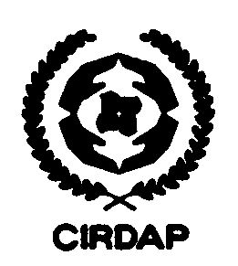
Centre on Integrated Rural Development for Asia and the Pacific (CIRDAP)
17 Topkhana Road, GPO Box 2883, Dhaka 1000, Bangladesh

Phone: 880-2- 9586509 – 10 Fax: 880-2-9562035 E-mail: training@cirdap.org

PARTICIPANT MEDICAL FORM
(Filled by registered Physician)
(Please type to fill in the form or use capital letter if hand written)
1. Name:

2. Please write the name of the Programme you will attend with date and venue:

3. Designation and Name of Organization:

4. Weight: (kg) | 5. Height: |  |  |  | 6. Blood group:
7. Blood pressure: |  |  |  | 8. Blood sugar: (fasting); ( after 2hrs)
9. If the person have any allergy tendency: |  | If yes, please specify:
10. Comments on general physical appearance:

11. Comments on his/her mental health:
12. Comments on TB and other branchial test:
13. Name of physician (Block letter):  Registration no. :  Name of affiliated hospital:  Place, City, Country:  Mobile/Cell phone:  E-mail: |  |  | 14. Physicians signature and seal:

